WAI ZHI YAN 207258

Architecture Design Assignment

1. You are working in company XYZ required you to develop a design package for library, and develop the following diagram:
2. Class Diagram
3. Sequence Diagram for borrow a book from library

Answer:

1. Class Diagram

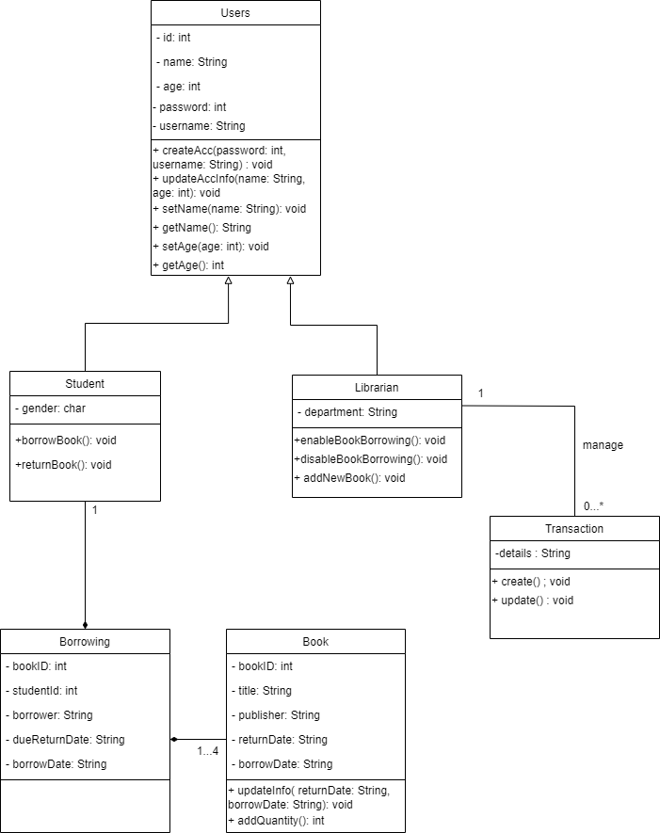

1. Sequence Diagram